USER MANUAL

For

Module: Guest House – Meal Booking

Introduction – Guest House Booking

Introduction to Meal Booking System
The Meal Booking System has been introduced by Chaudhary Ranbir Singh University to provide a convenient, transparent, and efficient platform for students, faculty members, and hostel residents to book meals online. The system eliminates manual meal registration processes and enables users to reserve their meals in advance through the university portal.
The primary objective of the Meal Booking System is to streamline meal management, reduce food wastage, improve dining services, and ensure better planning of meal preparation based on actual bookings. Through this system, users can view available meal options, book meals for specific dates, modify or cancel bookings within the permitted time frame, and track their booking history.
The Meal Booking System is accessible through the university's online portal and can be used from any internet-enabled device. The platform offers a user-friendly interface that allows authorized users to manage their meal preferences efficiently while ensuring secure access through individual login credentials.
This user manual provides step-by-step instructions for accessing the system, booking meals, viewing booking details, managing meal schedules, and resolving common issues. Users are advised to read the manual carefully to make effective use of all available features and services.
The online portal supports various student and hostel-related services and provides a centralized platform for user management and service access.

International Guest House Booking Request Page
This page allows users to access the Guest House Management System for booking accommodation, reserving meals, and downloading payment slips related to guest house services.
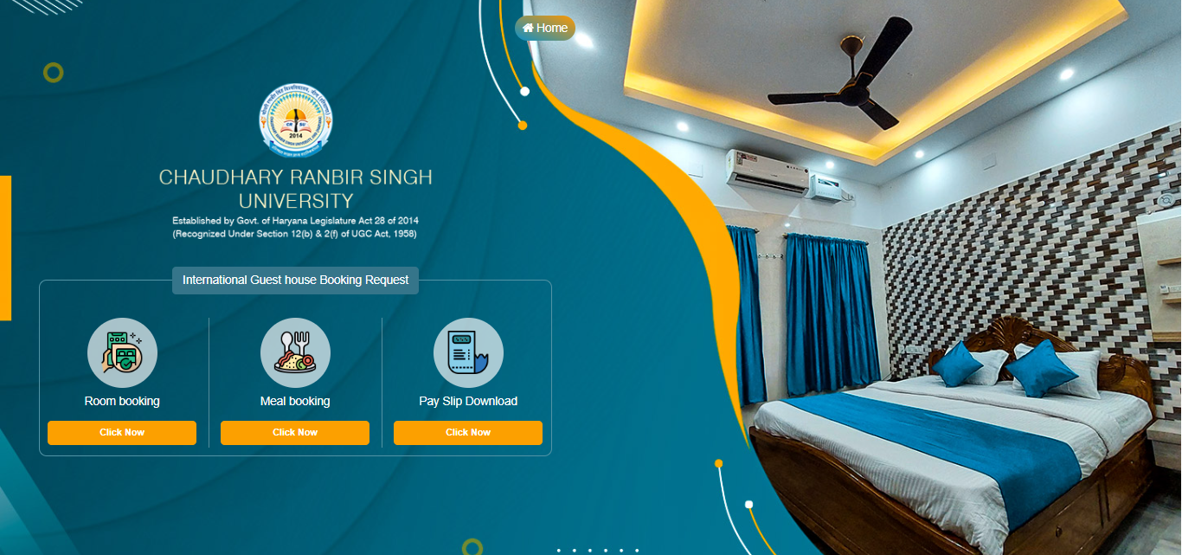
Available Options:
- Room Booking
- Click the "Click Now" button under Room Booking.
- Used for submitting a guest house accommodation request.
- Users can select room requirements and proceed with the booking process.

- Meal Booking
- Click the "Click Now" button under Meal Booking.
- Allows users to request meal services for their stay.
- Meal preferences and booking details can be submitted through this module.
- Pay Slip Download
- Click the "Click Now" button under Pay Slip Download.
- Enables users to download or print payment receipts/pay slips related to guest house bookings.

- Room Booking:
Guest House Availability & Booking: Availability shown on the screen is subject to change until the booking is successfully submitted.

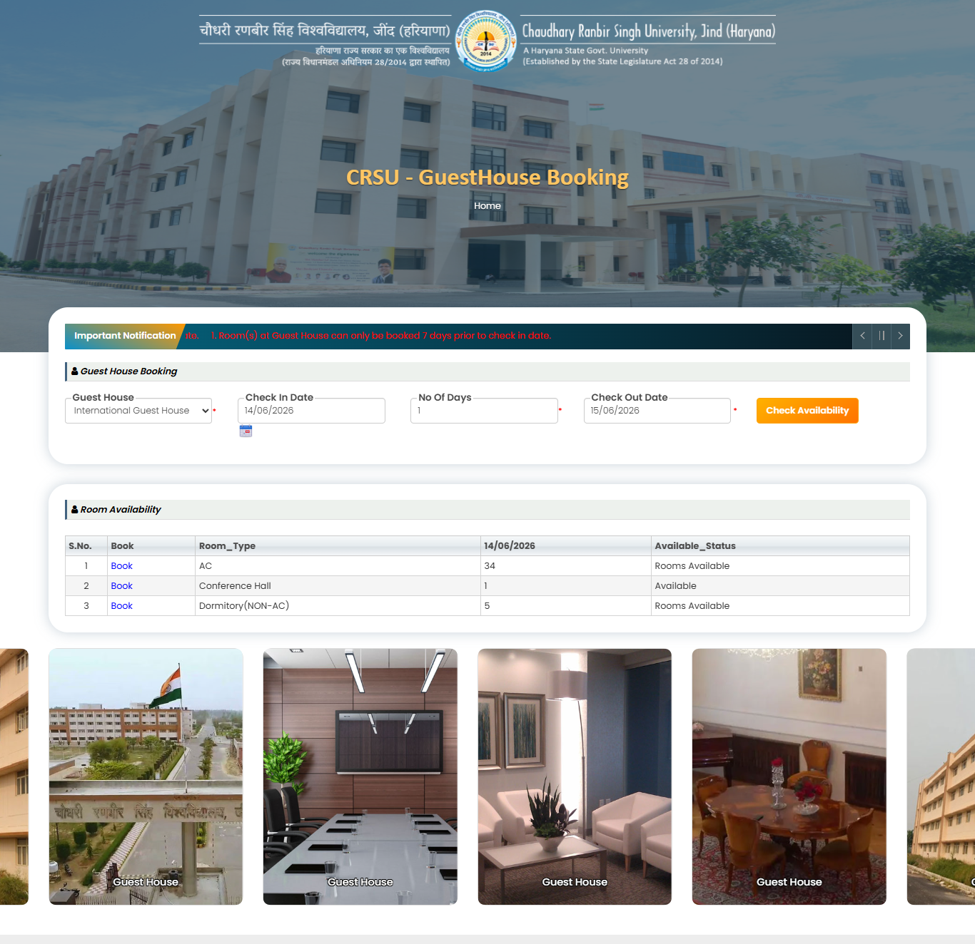
- Open the Guest House Booking page from the Guest House Management System.
- Review the Important Notification displayed at the top of the page.
- Select the required Guest House from the dropdown list.
- Choose the Check-In Date using the calendar control.
- Enter the Number of Days for the stay.
- Verify the automatically generated Check-Out Date.
- Click the Check Availability button.
- The system displays the Room Availability details for the selected dates.
- Review the available room categories (e.g., AC Room, Conference Hall, Dormitory).
- Check the Available Status and number of available rooms.
- Click the Book link corresponding to the desired room type.
- The system redirects to the room booking request page.
- Enter the required guest and booking details.
- Submit the booking request for further processing.
- Save the booking reference number for future tracking.
- Use the Home button to return to the portal homepage if required.
- Room booking is allowed only as per the booking rules mentioned in the notification section.

- New Guest House Booking Page:
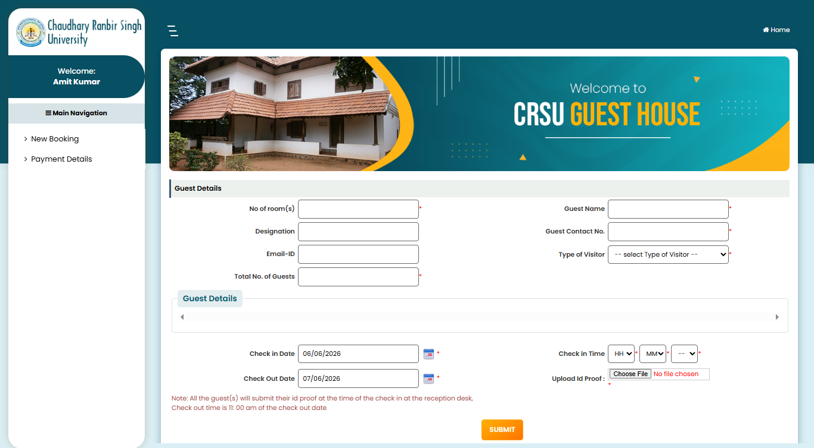
- Navigate to Main Navigation → New Booking.
- Enter the Number of Room(s) required for the stay.
- Enter the Guest Name in the provided field.
- Enter the Designation of the guest.
- Enter the Guest Contact Number.
- Provide the Email ID of the guest.
- Select the Type of Visitor from the dropdown list.
- Enter the Total Number of Guests staying in the guest house.
- In the Guest Details section, add details of all guests accompanying the booking.
- Select the Check-In Date using the calendar icon.
- Select the Check-In Time by choosing the Hour (HH), Minute (MM), and AM/PM values.
- Verify the Check-Out Date displayed by the system.
- Upload a valid Identity Proof using the Choose File button.
- Ensure all mandatory fields marked with a red asterisk (*) are completed.
- Review the booking information entered on the page.
- Click the SUBMIT button to submit the guest house booking request.
- Note that all guests must submit their identity proof at the reception during check-in.
- Check-out time is 11:00 AM on the check-out date.
- After successful submission, the system generates the booking request for further processing.
- Use the Home button to return to the dashboard/home page if required.

Guest House Booking Preview & Payment Page:
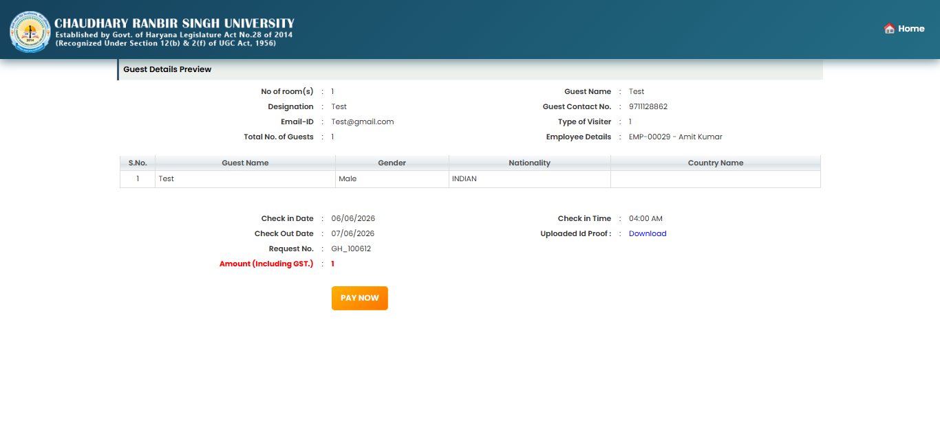
- Review the Guest Details Preview displayed on the screen.
- Verify the Number of Room(s) requested.
- Confirm the Guest Name entered in the booking request.
- Verify the Designation of the guest.
- Check the Guest Contact Number for accuracy.
- Verify the registered Email ID.
- Confirm the selected Type of Visitor.
- Review the Total Number of Guests included in the booking.
- Verify the Employee Details associated with the booking request.
- Review the guest information listed in the details table, including:
- Guest Name
- Gender
- Nationality
- Country Name
- Verify the Check-In Date.
- Verify the Check-Out Date.
- Confirm the selected Check-In Time.
- Review the generated Request Number for future reference.
- Click the Download link to view the uploaded identity proof, if required.
- Verify the Amount (Including GST) payable for the booking.
- Ensure all displayed booking details are correct before proceeding.
- Click the PAY NOW button to proceed to the online payment gateway.
- Complete the payment process using the available payment options.
- After successful payment, save the payment receipt and booking reference number for future tracking.
- Use the Home button to return to the Guest House portal homepage if required.
Guest House Booking Preview & Payment Page:
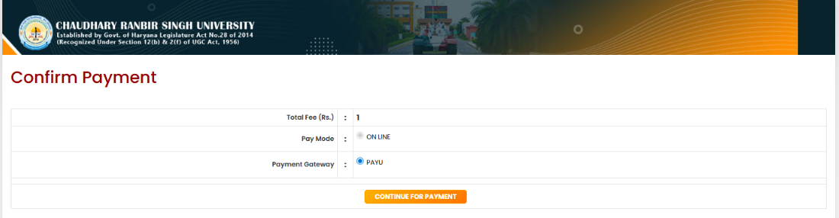
- The Confirm Payment page is displayed before proceeding to the online payment gateway.
- Verify the Total Fee (Rs.) amount shown on the screen.
- Ensure that the Pay Mode is selected as ONLINE.
- Check the selected Payment Gateway (e.g., PAYU).
- Review all payment details carefully before proceeding.
- If the displayed fee amount is correct, click the Continue for Payment button.
- The system will redirect you to the selected payment gateway's secure payment page.
- Complete the payment using your preferred payment method (Debit Card, Credit Card, Net Banking, UPI, etc., as supported by the gateway).
- Do not refresh, close, or navigate away from the browser window during the payment process.
- After successful payment, you will be redirected back to the portal and receive a payment confirmation message.
- Save or print the payment receipt for future reference.
- In case of payment failure, check the transaction status before attempting another payment to avoid duplicate transactions.
- Contact the university helpdesk if the payment amount is deducted but the status is not updated in the portal.
Fields Description
- Total Fee (Rs.): Displays the payable fee amount.
- Pay Mode: Indicates the selected mode of payment (Online).
- Payment Gateway: Shows the gateway through which the payment will be processed.
- Continue for Payment: Button used to proceed to the payment gateway and complete the transaction.

Payment Gateway Checkout Page:
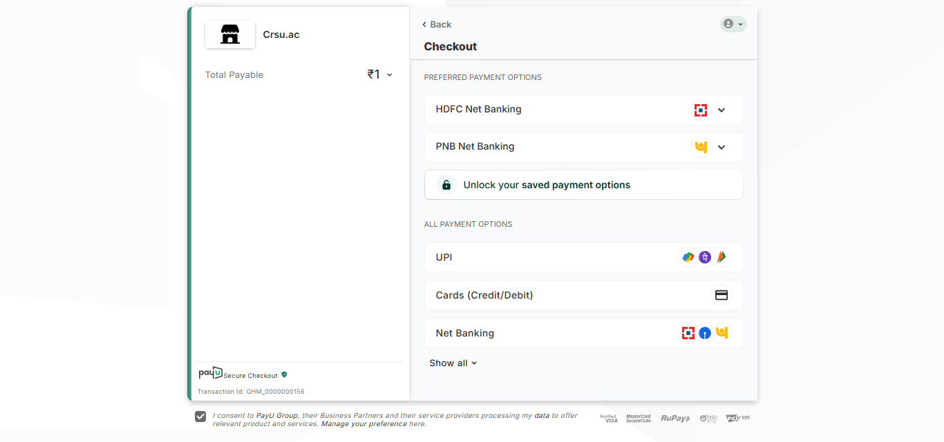

User Manual – Payment Gateway Checkout Page
- The Checkout page is displayed after clicking Continue for Payment on the Confirm Payment page.
- Verify the Total Payable Amount displayed on the left panel.
- Review the available payment methods under Preferred Payment Options and All Payment Options.
- Select your preferred payment method from the available options:

  - UPI
  - Credit/Debit Card
  - Net Banking
  - Any bank-specific quick payment option (if available)
- For UPI Payment:
- Select the UPI option.
- Enter your UPI ID or choose a supported UPI application.
- Approve the payment request in your UPI app.
- For Credit/Debit Card Payment:
- Select the Cards (Credit/Debit) option.
- Enter card number, cardholder name, expiry date, and CVV.
- Complete OTP authentication, if required.
- For Net Banking Payment:
- Select Net Banking.
- Choose your bank from the available list.
- Log in to your bank account and authorize the payment.
- Click the appropriate payment confirmation button after entering the required details.
- Wait for the transaction to be processed and do not refresh or close the browser window during payment.
- Upon successful payment, the system will redirect you back to the university portal.
- Verify that the payment status is updated successfully in the portal.
- Download or print the payment receipt for future reference.
- If the payment fails, check the transaction status before attempting another payment.
- Contact the university support team if the amount is debited but the payment status is not updated.

Fields Description
- Total Payable Amount: Displays the amount to be paid.
- Preferred Payment Options: Frequently used or recommended payment methods.
- UPI: Payment through UPI-enabled applications.
- Cards (Credit/Debit): Payment using credit or debit cards.
- Net Banking: Payment through internet banking services.
- Show All: Displays additional payment options available through the payment gateway.
- Back: Returns to the previous payment confirmation page.

Payment Confirmation: After Successful Payment, Payment Confirmation window will be displayed.

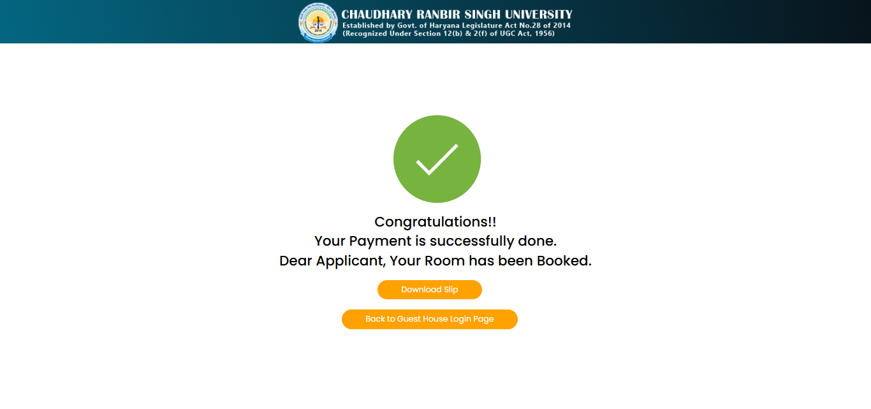

User Manual – Payment Success Confirmation Page
- The Payment Success Confirmation page is displayed after the payment has been completed successfully.
- A success message is shown confirming that the payment transaction was successful.
- Verify the confirmation message to ensure that the booking has been completed.
- Review the details displayed on the screen before leaving the page.
- Click the Download Slip button to download and save the payment receipt/booking confirmation slip.
- Store the downloaded slip for future reference and record-keeping.
- After downloading the slip, click Back to Guest House Login Page to return to the login page.
- Use the downloaded slip as proof of payment and room booking, if required.
- Ensure that the slip has been downloaded successfully before closing the browser.
- If the confirmation page does not appear after payment, verify the transaction status and contact the support team if necessary.

Fields Description
- Success Icon (✔): Indicates that the payment has been processed successfully.
- Confirmation Message: Displays the successful payment and room booking confirmation.
- Download Slip: Downloads the payment receipt and booking confirmation slip.
- Back to Guest House Login Page: Redirects the user to the Guest House login page.

