USER MANUAL

For

Module: Electricity Billing

Introduction – Electricity Billing

The Electricity Billing Module is a computerized system designed to automate and simplify the process of electricity billing and consumer management. This module helps electricity departments, utility providers, and organizations efficiently manage customer information, meter readings, bill generation, payment records, and reporting activities.
The purpose of this user manual is to provide users with a clear understanding of the features, functions, and operational procedures of the Electricity Billing Module. It serves as a step-by-step guide for administrators, billing operators, and end users to effectively use the system without technical difficulty.
The module enables users to:
- Manage consumer registration and profiles
- Record and update meter readings
- Generate electricity bills automatically
- Calculate charges based on tariff rates
- Track payments and outstanding dues
- Generate reports and billing summaries
- Maintain accurate and secure billing records
This user manual includes detailed instructions for system login, dashboard navigation, consumer management, billing operations, payment processing, report generation, and troubleshooting. The manual is intended to improve user efficiency, reduce operational errors, and ensure smooth functioning of the billing process.
The Electricity Billing Module is designed with a user-friendly interface, secure database management, and automated workflows to provide accurate, transparent, and reliable billing services. It supports both manual and smart meter-based billing systems and can be integrated with online payment platforms for enhanced customer convenience.

Page Visit: Registered user must visit to URL to download various report as per the Meter No

URL: https://crsuiums.com/Electricity_Bill/Elec_Bill_Payment.aspx

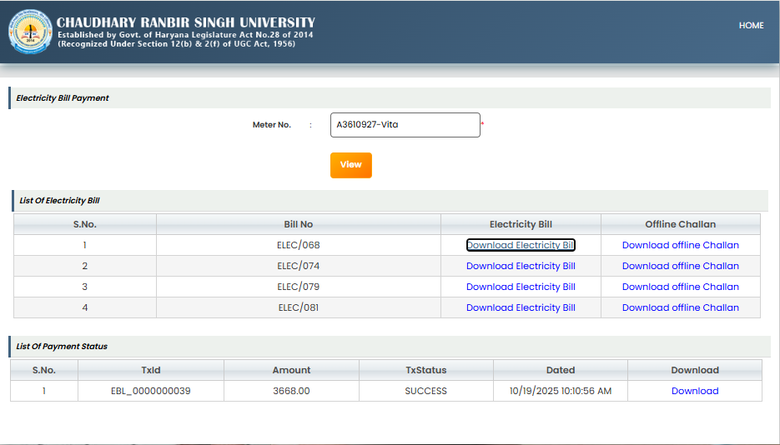
Download Payment Status
Download offline challan
Download Electricity Bill
Enter Meter Number

Electricity Bill Payment Page – User Manual Points

Purpose
This page is used to:
- View electricity bill details for a specific meter.
- Download electricity bills.
- Download offline challans.
- Check payment transaction status.
- Download payment receipt/details.

Steps to Use the Page

1. Enter Meter Number
- In the Meter No. field, enter the valid electricity meter number.
- Example: A3610927-Vita

2. Click on “View”
- Click the View button to fetch bill details related to the entered meter number.

List of Electricity Bills
After clicking View, the system displays all available electricity bills in the List Of Electricity Bill section.

Details Available
- S.No. – Serial Number
- Bill No – Unique bill number
- Electricity Bill – Link to download bill
- Offline Challan – Link to download challan for offline payment

Actions
- Click Download Electricity Bill to download the bill copy.
- Click Download offline Challan to download the challan for bank/offline payment.

Payment Status Section
The List Of Payment Status section displays payment transaction details.

Details Available
- S.No. – Serial No
- TxId – Transaction ID
- Amount – Paid amount
- TxStatus – Payment status (e.g., SUCCESS)
- Dated – Payment date and time
- Download – Download payment receipt/details

Actions
- Click Download to download the payment receipt or transaction details.

Important Notes
- Ensure the meter number is entered correctly.
- Bills and challans can only be downloaded if records are available.
- Payment status will appear only after successful transaction processing.
- Keep downloaded receipts for future reference and audit purposes.

Electricity Bill
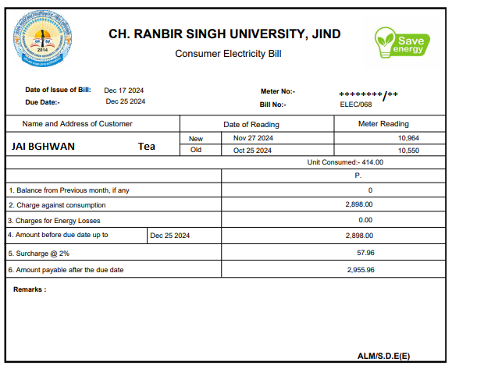

Offline challan
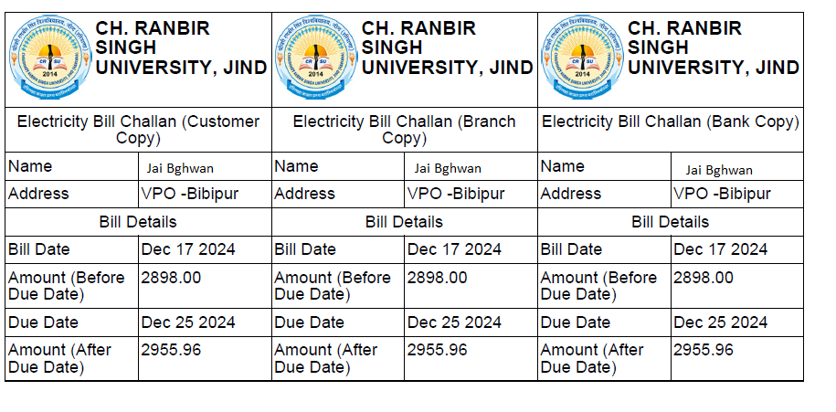

E-PAYMENT RECEIPT
