USER MANUAL

For

Module: Guest House – Pay Slip

Introduction – Guest House – Pay Slip Download

Guest House – Pay Slip
The Guest House – Pay Slip module enables users to download and print the payment receipt for their Guest House booking requests. This feature provides a detailed record of payments made for both Meal Requests and Room Requests submitted through the system.
Using this module, users can:
- View the payment details of approved Guest House requests.
- Download the pay slip in PDF format for future reference.
- Print the pay slip as proof of payment.
- Access payment information related to room bookings and meal bookings.
- Verify transaction details, payment status, booking information, and applicable charges.
The downloaded pay slip serves as an official payment record and can be used for administrative and reimbursement purposes, where applicable.

International Guest House Booking Request Page
This page allows users to access the Guest House Management System for booking accommodation, reserving meals, and downloading payment slips related to guest house services.
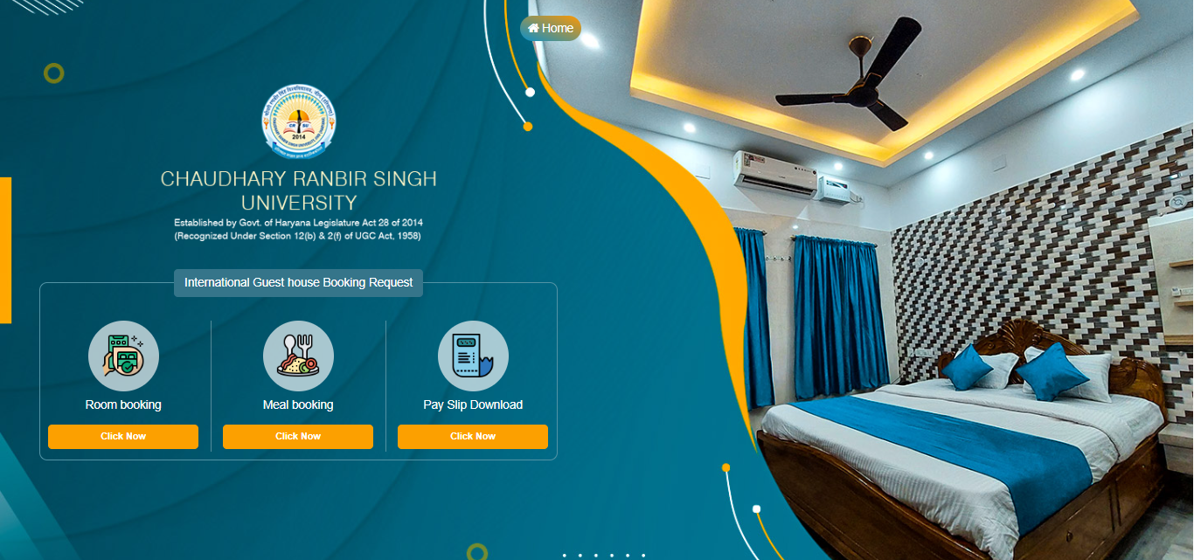
Click here to Download the Pay slip
Available Options:
- Room Booking
- Click the "Click Now" button under Room Booking.
- Used for submitting a guest house accommodation request.
- Users can select room requirements and proceed with the booking process.

- Meal Booking
- Click the "Click Now" button under Meal Booking.
- Allows users to request meal services for their stay.
- Meal preferences and booking details can be submitted through this module.
- Pay Slip Download
- Click the "Click Now" button under Pay Slip Download.
- Enables users to download or print payment receipts/pay slips related to guest house bookings.

Payslip Download : This page is used to download the payment receipt (Pay Slip) for Guest House Room and Meal booking requests, providing users with an official record of their booking and payment details for reference, verification, and administrative purposes.

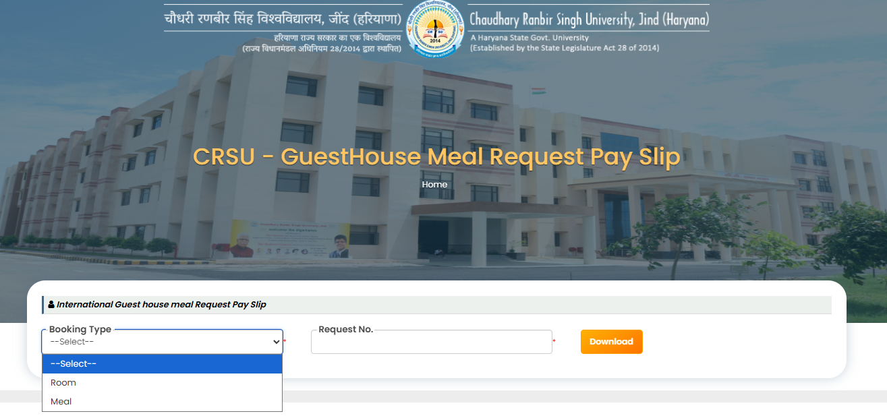

- Open the Guest House Meal/Room Request Pay Slip page.
- Select the Booking Type from the dropdown list.
- Choose Room to download the Room Booking Pay Slip.
- Choose Meal to download the Meal Booking Pay Slip.
- Enter the Request Number in the provided field.
- Verify that the entered Request Number is correct.
- Click the Download button.
- The system validates the booking details.
- Upon successful validation, the pay slip is generated.
- The pay slip is downloaded in PDF format.
- Users can save the pay slip for future reference.
- Users can print the downloaded pay slip if required.
- The pay slip contains booking and payment-related information.
- Only valid Request Numbers are eligible for pay slip generation.
- Ensure the correct Booking Type is selected before downloading the pay slip.

Room Payment Receipt : The downloaded pay slip for the room booking is displayed below.

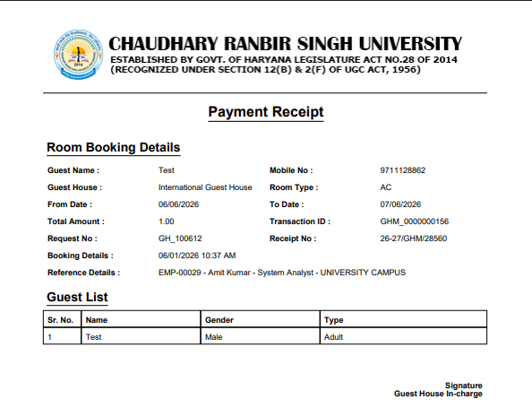

Meal Payment Receipt: The downloaded meal slip for the room booking is displayed below.

