USER MANUAL

For

Module: Hostel Management

Introduction – Hostel Management

The Hostel Management System of Chaudhary Ranbir Singh University is a comprehensive online platform designed to streamline and automate the entire hostel admission and management process for students. The system provides a centralized digital solution where students can apply for hostel accommodation, complete their application forms, upload necessary documents, and submit hostel fees securely through an online mode.
This system has been developed to enhance efficiency, transparency, and accessibility in hostel-related processes. It eliminates the need for manual paperwork and reduces delays in application processing, thereby ensuring a faster and more organized workflow for both students and university administration.
Through this portal, students can easily register and log in to access hostel services. They can fill in personal and academic details, select hostel preferences (if applicable), and submit their applications within a few simple steps. The system also allows students to track the status of their application, ensuring real-time updates and clear communication.
In addition, the Hostel Management System supports secure fee submission, making the payment process convenient and reliable. It also helps administrators manage seat allocation, verify applications, and maintain hostel records efficiently.

- Student Hostel Registration : This page is used by students of Chaudhary Ranbir Singh University to apply for hostel accommodation, continue hostel registration, and log in using registration credentials.

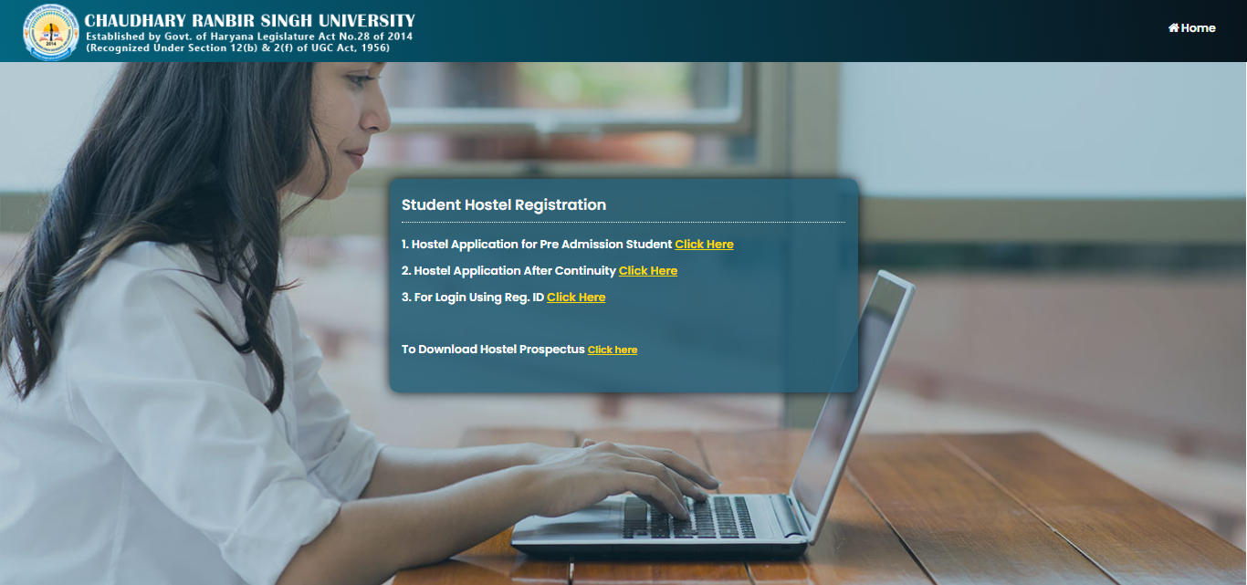

Main Features Available on the Page
- Hostel Application for Pre-Admission Students
New students can apply for hostel accommodation before admission confirmation.
- Hostel Application After Continuity
Existing/continuing students can submit hostel applications for the next academic session.
- Login Using Registration ID
Students can log in using their hostel registration ID and password.
- Download Hostel Prospectus
Hostel rules, fee structure, and guidelines can be downloaded.
- Login Options Available
- Login using Enrollment No. /Roll No.
- Login using Registration No.
- Registration using Class Roll No.
- Registration using Enrollment No. /Hostel Registration No.

Student Hostel Registration Form Page
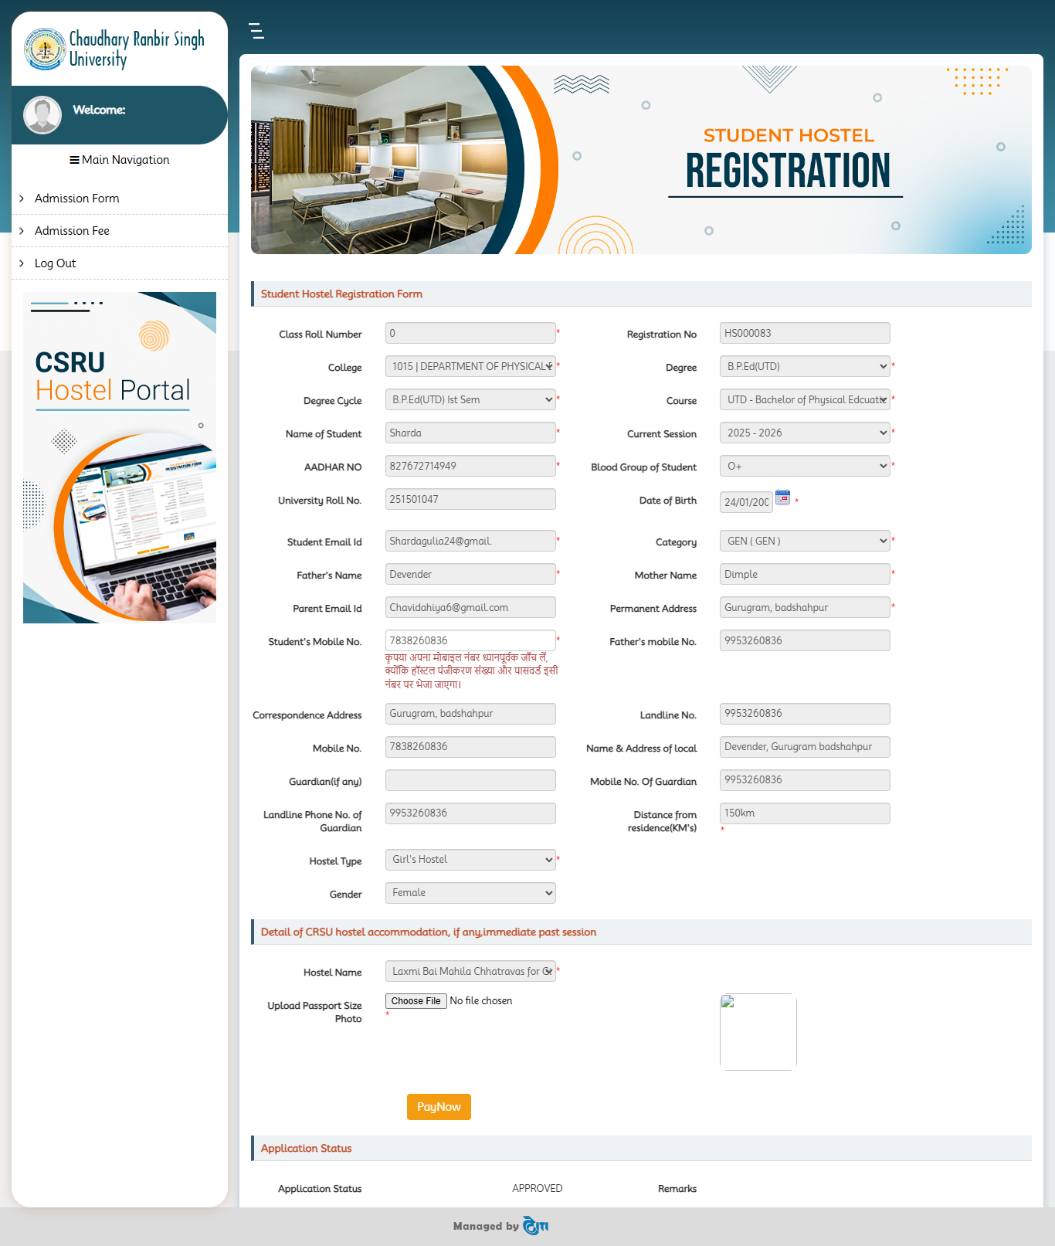

Student Hostel Registration Form Page : This page is used by students to complete and submit the hostel accommodation registration form, upload required documents, and pay the hostel registration/application fee.

Navigation Path
- Login to the Hostel Portal.
- From the left navigation menu, select:
  - Admission Form

Main Sections of the Page

1. Student Information
The following student details are displayed or required:
- Class Roll Number
- Registration Number
- College Name
- Degree
- Degree Cycle
- Course
- Student Name
- Current Session
- Aadhar Number
- Blood Group
- University Roll Number
- Date of Birth
- Student Email ID
- Category
- Father’s Name
- Mother’s Name
- Parent Email ID
- Permanent Address
- Student Mobile Number
- Father’s Mobile Number

2. Communication & Guardian Details
Students must provide:
- Correspondence Address
- Mobile Number
- Guardian Name (if any)
- Guardian Mobile Number
- Landline Number
- Name & Address of Local Guardian
- Distance from Residence (in KM)

3. Hostel Details
Students need to select:
- Hostel Type
Example:
- Girl’s Hostel
- Boy’s Hostel
- Gender
- Previous Hostel Accommodation Details (if applicable)
- Hostel Name

4. Upload Passport Size Photograph
- Click Choose File
- Select a recent passport-size photograph from the system.
- Upload the image in the prescribed format and size.

5. Fee Payment
- Click the Pay Now button to proceed with hostel/application fee payment.
- Complete payment using the available online payment options.

6. Application Status
After submission, the system displays:
- Application Status
Example:
  - Approved
  - Pending
  - Rejected
- Remarks (if any)
3 Confirm Payment Page : This page is used to verify hostel registration fee details and proceed to online payment through the available payment gateway.

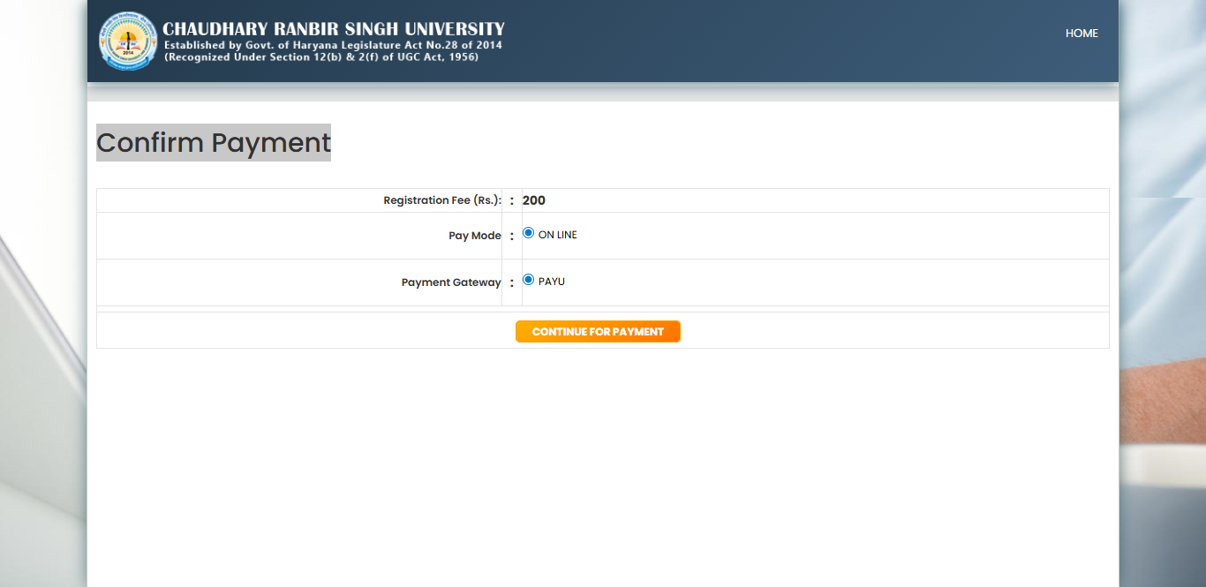

- Verify the registration fee amount displayed on the screen.
- Ensure the payment mode is selected as Online.
- Confirm the payment gateway option.
- Click the CONTINUE FOR PAYMENT button.
- The system redirects to the secure payment gateway page.
- Complete the payment using available options such as:
- Debit Card
- Credit Card
- Net Banking
- UPI
- Wallets (if available)
Checkout Page: The Checkout page allows users to complete payment securely for their transaction using multiple payment methods.
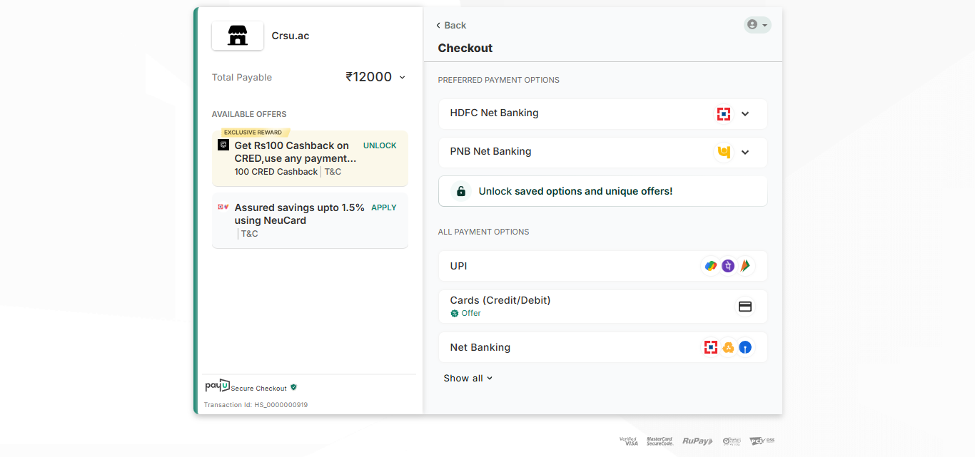
- Displays merchant/service name and payable amount.
- Shows available cashback and promotional offers.
- Users can unlock or apply eligible offers.
- Preferred payment options are displayed for quick payment.
- Supports HDFC Net Banking and PNB Net Banking.
- Provides option to unlock saved payment methods and offers.
- Supports UPI payment method.
- Allows payment through Credit/Debit Cards.
- Supports Net Banking transactions.
- Users can view additional payment methods using “Show all”.
- Secure checkout and payment security badges are displayed.
- Transaction ID is available for payment tracking.
- Back button allows navigation to the previous page.
- Users should avoid refreshing the page during payment.
- Payment requires authentication such as OTP or bank authorization.
Payment Receipt Download: After successful payment student can download the Payment Receipt and Application form from admission from section.
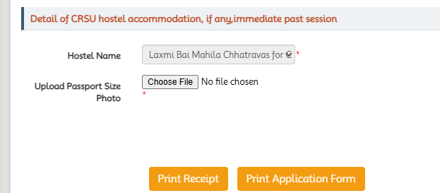
Download Print Receipt
Click here
Download the application from Click here

